**BLOCKCHAIN TECHNOLOGY FOR AGRICULTURAL SUPPLY CHAIN**

**Abstract**

In this project we are using IOT network and Blockchain security technology in agriculture food supply chain. In propose work IOT network will be setup in agriculture farms and this IOT will sense food quality growing farms and then report to its nearest cluster head and cluster head will report to base station. Base station will collect food quality data from Cluster Head and then store that data in decentralized Blockchain nodes. This data can be access by various users such as distributors, suppliers, farmers and consumers to know the quality of the food. All existing techniques were using centralized server (single main server) to store data and if this server hack by malicious users, then they can easily alter data on that servers and user’s may get wrong or fake data and there is no proper software to detect that alteration and to overcome from this problem Blockchain technology has been introduced. Blockchain support decentralized (data stores at multiple nodes) storage and each node will store data as block of transaction by associating each block with hash code and whenever new data arrive for storage then all nodes will verify hashcode of existing blocks and if all nodes contains same hashcode then data will be consider as secured and unaltered and then new block will be added. If any node report incorrect hashcode then that node considers as attacked and then collect data from genuine nodes. Above verification of hash code is consider as PROOF OF WORK.

**Keywords:** Block chain technology, agricultural applications, hash code, Internet of things ()

**INDEX**

**Abstract**

**CHAPTER 1: INTRODUCTION**

**1.1 AIM OF THE PROJECT**

**1.2 SCOPE OF THE PROJECT**

**1.3 OBJECTIVE OF THE PROJECT**

**1.4 PROBLEM STATEMENT**

**1.5 Introduction**

**CHAPTER 2: LITERATURE SURVEY**

**2.1. Blockchain technology**

**CHAPTER 3: EXISTING SYSTEM**

**3.1 Existing Techniques and Drawbacks**

**CHAPTER 4: PROPOSED METHOD**

**CHAPTER 5**: **SOFTWARE AND HARDWARE REQUIRMENT**

**5.1 HARDWARE REQUIREMENTS**

**5.2 SOFTWARE REQUIREMENTS**

**5.3 Hardware Interfaces**

**CHAPTER 6: RESULT**

**CHAPTER 7: Conclusion**

**REFERENCES**

**APPENDIX: PYTHON**

**CHAPTER 1**

**INTRODUCTION**

**1.1 AIM OF THE PROJECT**

Transparency and Traceability: Enable real-time visibility into the entire supply chain, from farm to consumer. Provide a tamper-resistant and immutable ledger that records every transaction and movement of goods. Reduced Fraud and Counterfeiting: Mitigate the risk of fraud by ensuring that the information recorded on the blockchain is secure and cannot be altered. Authenticate the origin of agricultural products, reducing the possibility of counterfeit goods entering the supply chain.

**1.2 SCOPE OF THE PROJECT**

Supply Chain Mapping: Identify and map the entire agricultural supply chain, including farmers, producers, distributors, retailers, and consumers. Data Collection and Integration: Determine the types of data to be recorded on the blockchain, such as crop information, production methods, transportation details, quality assessments, and more. Integrate data from IoT devices, sensors, and other sources to ensure real-time and accurate information.

**1.3 OBJECTIVE OF THE PROJECT**

Enhanced Transparency: Increase visibility into the entire agricultural supply chain by providing a transparent and immutable ledger of transactions and movements of agricultural products. Improved Traceability: Enable precise tracking of the origin, production processes, and distribution of agricultural products, reducing the time and effort required for traceability in case of contamination or quality issues.

**1.4 PROBLEM STATEMENT**

Our project elaborates the major challenges faced by the agriculture industry namely, the food production and food supply chain inefficiency.

**1.5 Introduction**

Blockchain is a decentralized and distributed ledger technology that enables secure, transparent, and tamper-resistant record-keeping of transactions. It serves as the underlying technology for cryptocurrencies like Bitcoin, but its applications go beyond digital currencies. Here are some key aspects of blockchain:

**1. Decentralization:** Unlike traditional centralized systems, blockchain operates on a network of computers (nodes) that work together to validate and record transactions. This decentralized nature enhances security and eliminates the need for a central authority.

**2. Blocks and Chain:** Transactions are grouped together into blocks, and each block contains a reference to the previous block, creating a chain of blocks. This structure ensures the integrity of the entire transaction history, as altering one block would require changing all subsequent blocks, making tampering highly impractical.

**3. Consensus Mechanisms:** Blockchain networks use consensus mechanisms to agree on the validity of transactions and the order in which they are added to the blockchain. Common consensus mechanisms include Proof of Work (used by Bitcoin) and Proof of Stake.

**4. Smart Contracts:** These are self-executing contracts with the terms of the agreement directly written into code. Smart contracts automatically enforce and execute the terms when predefined conditions are met. Ethereum is a notable blockchain platform that supports smart contracts.

**5. Transparency and Immutability:** Transactions recorded on the blockchain are visible to all participants in the network, promoting transparency. Once a block is added to the blockchain, it becomes extremely difficult to alter, ensuring immutability and security.

**6. Cryptocurrencies:** Blockchain's most well-known application is in the creation of digital currencies, such as Bitcoin and Ethereum. These cryptocurrencies use blockchain to enable peer-to-peer transactions without the need for a central authority.

**7. Distributed Ledger Technology (DLT):** The term "blockchain" is often used interchangeably with Distributed Ledger Technology (DLT). DLT encompasses a broader range of technologies that distribute and synchronize data across multiple locations, of which blockchain is a specific type.

**8. Use Cases:** Beyond cryptocurrencies, blockchain has applications in various industries, including finance (for secure and transparent transactions), supply chain management (for traceability and authenticity), healthcare (for secure and interoperable health records), and more.

While blockchain technology has the potential to revolutionize various sectors, it also faces challenges, including scalability issues, energy consumption concerns (especially for Proof of Work systems), and regulatory uncertainties. Ongoing developments and advancements aim to address these challenges and expand the scope of blockchain applications.

**IOT:**

The Internet of Things (IoT) refers to the network of interconnected devices that communicate and exchange data with each other through the internet. These devices, which can range from everyday objects like household appliances and industrial machinery to wearable devices and sensors, are embedded with sensors, software, and other technologies that enable them to collect and exchange data.

In recent years, the agricultural industry has been undergoing a transformative shift, driven by the integration of innovative technologies. One such groundbreaking technology poised to revolutionize the agricultural supply chain is blockchain.

Blockchain, originally designed as the underlying technology for cryptocurrencies like Bitcoin, offers a decentralized and transparent platform for recording and verifying transactions. When applied to the agricultural supply chain, it brings about a paradigm shift in how information is shared, transactions are conducted, and trust is established among stakeholders.

**Understanding Blockchain Technology:**

At its core, a blockchain is a distributed and decentralized ledger that records transactions across a network of computers. Each transaction, or block, is securely linked to the previous one, forming a chain of blocks.

What sets blockchain apart is its tamper-resistant nature; once a block is added to the chain, it becomes nearly impossible to alter the information it contains. This ensures the integrity and transparency of the entire transaction history.

**Key Components and Features:**

**Decentralization:** Unlike traditional centralized systems, blockchain operates on a peer-to-peer network, eliminating the need for intermediaries. This decentralization fosters trust and reduces the risk of manipulation.

**Immutability:** Once data is recorded on the blockchain, it cannot be changed or deleted. This immutability ensures the integrity of the information, making the blockchain a reliable source of truth.

**Transparency:** All participants in the network have access to the same information, promoting transparency across the supply chain. Each participant can view the entire transaction history, enhancing visibility into processes and transactions.

**Smart Contracts:** Smart contracts are self-executing contracts with the terms of the agreement directly written into code. In the agricultural supply chain, these contracts automate and enforce agreements, such as payment upon delivery or adherence to quality standards.

**Application in the Agricultural Supply Chain:**

**Traceability and Provenance:** Blockchain enables precise traceability, allowing stakeholders to track the journey of agricultural products from farm to table. This is particularly crucial for ensuring food safety and quality.

**Efficient Record-Keeping:** Tedious paperwork and manual record-keeping are streamlined through blockchain, reducing administrative burdens and minimizing the risk of errors.

**Supply Chain Optimization:** Real-time monitoring and automation of processes lead to a more optimized and efficient supply chain. This includes inventory management, transportation logistics, and overall operational efficiency.

**Fraud Prevention:** The transparent and tamper-resistant nature of blockchain reduces the risk of fraud and counterfeiting. Participants can trust the accuracy of the information recorded on the blockchain.

**Empowering Stakeholders:** Farmers, producers, distributors, and consumers can benefit from increased transparency, fairer pricing, and improved market access, fostering a more inclusive and empowered agricultural ecosystem.

**Conclusion:** Blockchain technology holds immense promise for transforming the agricultural supply chain into a more transparent, efficient, and trustworthy system. As we embark on this journey, collaboration among industry stakeholders and a commitment to standardization will play pivotal roles in realizing the full potential of blockchain in agriculture. This introduction marks the beginning of a new era, where technology and agriculture converge to create a sustainable and resilient supply chain for the benefit of all participants.

Blockchain technology in agriculture improves food safety by allowing information to be traced across the food supply chain. The capacity of blockchain to store and manage data enables traceability, which is utilized to aid in creating and implementing technologies for intelligent farming and index-based crop insurance. It represents a significant advancement in the field of contemporary agriculture.

You can go for Blockchain Quality Engineer training to get hands-on with blockchain. With the growing popularity of Bitcoin and other cryptocurrencies, you must have heard a lot about blockchain technology, but its impact on the agriculture industry is huge. ICT (information and communication technology) employed for databases to track data and sustain information flow is powered by blockchain technology.

Instead of a single server and administrator, they grant access to all network members. Multiple parties may then access and validate new changes to the database, providing more security and reducing the possibility of corruption.

**Blockchain in Agriculture:**

The Revolution Blockchain technology or blockchain in agriculture can track all types of information about plants, such as seed quality, crop growth, and even the travel of a plant after it leaves the farm. This data can improve supply chain transparency and eliminate concerns associated with illegal and unethical operations.

They can also help track contamination or other issues back to their source in the case of a recall. The major aim of these technologies is sustainability and food security. Consumers can make correct purchasing decisions when they have this amount of openness. They frequently use this information to reward farmers and producers who implement good farming techniques.

**How to Apply Blockchain Technology in Agriculture?**

There are various blockchain uses in the agricultural sector, and more are being developed based on recent technological advancements. To analyze the key uses of blockchain, it is feasible to divide it into four broad categories:

• Intelligent Farming

• Food Supply Chain

• Insurance for Agriculture

• Agricultural Product Transactions

• Smart Agriculture

The technique of employing numerous current technical breakthroughs to increase the efficiency and dependability of the farming process is known as smart farming or smart agriculture.

It incorporates information and communication technology (ICT), the internet of things (IoT), multiple sensors, machine learning technologies, and numerous data collecting and analysis equipment such as unmanned aerial vehicles. The connection between smart technology and farming is still new, but with the right security system in place, it can make operations much easier to carry out.

All of the procedures in the old method of controlling smart technology are often centralized, which leads to different mistakes and distortions in data collecting. It also leaves the entire system vulnerable to a cyber-attack. One example is that environmental monitoring data is frequently administered and regulated by government agencies that have their interests in mind when managing this data.

This empowers them to distort facts to make judgments that suit their objective. It is now feasible to securely store information thanks to blockchain technology. The process's many players can generate the essential data at each stage, from seed through the sale of diverse agricultural products.

Blockchain helps to maintain data openness and assures that all statistics are completely irreversible. Blockchain's decentralization is by far its greatest strength in smart agriculture. This functionality also facilitates data delivery to the screens of many stakeholders while avoiding data loss and distortion. To ensure transparency, all transactions in a blockchain are time-stamped.

**1. Smart Farming Model**

The value and promise of blockchain in agriculture have led to several smart farming models, which help to bring the advantages of this technology together with IoT sensors. One such architecture has been developed for greenhouses, utilizing a private blockchain that can be managed centrally by the farmer.

Another general-purpose approach has been presented, which also uses IoT technologies and blockchain. The basic premise of this framework is to aid in the development of trust among blockchain participants. Numerous stakeholders may use smartphones to access data created at every stage of the farming process, from seeding to product sales.

**2. Smart Farming Technology**

Organizations such as Filament have begun to develop smart agricultural technology. One example is a business that sells products with smart farming technology that connects multiple networks to actual items. The business created a coin-sized piece of technology to assist users in safe transactions against a blockchain.

**3. Food Supply Chain**

The food supply chain has grown longer and more intensive than ever because of globalization trends. However, there are several challenges in the food supply chain, including food safety, quality, traceability, trust, and supply chain inefficiencies. These factors burden the economy and society and endanger customers' health. Blockchain technology contributes to the resolution of many of these challenges by facilitating the establishment of trust between producers and customers.

Offering specific product information within the blockchain can considerably increase transparency in this process. This has far-reaching repercussions for businesses and farmers alike. It enables businesses to raise the value of their products and hence increase their market competitiveness. It would also make it extremely improbable that providers of low-quality or fraudulent goods would be able to stay in business for very long if their tactics continued.

From a consumer standpoint, the usage of blockchain can be critical in providing people with trustworthy and legitimate information about how their food is produced. It may be used to address a wide range of customer concerns about food quality, safety, and environmental friendliness. Consumers have more flexibility to communicate with food producers as they better grasp their food production process.

When considering the benefits of blockchain from a regulator's perspective, it is evident that this technology provides reliable information to required entities to assist them in enforcing efficient regulations. Many firms have already begun to use blockchain for agriculture in their operations due to the multiple applications of blockchain in the food supply chain and management. Wal-Mart, JD.com, and Alibaba are all using traceability initiatives based on blockchain principles to closely track their whole sales, processing, and food manufacturing process.

**4. Agricultural Insurance**

Climate change in recent decades has rendered the entire agricultural process increasingly uncertain. Weather extremes have an impact on agricultural and livestock quality. Farmers often use agricultural insurance systems to mitigate the unpredictability of farming. Farmers can select from various insurance plans that vary in how payouts are calculated and losses are assessed.

A typical type of agricultural insurance, known as indemnity-based insurance, pays farmers according to the conclusions of a professional who examines the farm for damage. However, indemnity-based insurance has several restrictions related to damage estimation and a lack of information from the insurer, which negatively affects farmers and insurance companies.

Blockchain technology enables index-based insurance to give a superior alternative to indemnity-based insurance. It enhances overall insurance process accuracy by triggering a reimbursement based on a quantifiable indicator rather than the loss.

Blockchain can help to enhance index-based insurance in the following ways:

The payment basis can be changed to a timely and automatic criterion, such as weather data. This parameter may trigger the final payout depending on the explicitly established parameters of a smart contract.

Second, the system would use an oracle to provide all data sources, including weather and plant development information. This greatly improves the payment process and index determination. Etherisc, a Swiss-based business that assists farmers in obtaining decentralized crop insurance based on blockchain technology, is one of many companies using smart index insurance contracts.

These contracts are in use throughout the world and increase overall dependability. For example, they're currently being used by farmers in regions such as India to obtain crop insurance payments based on meteorological data. These payments increase the overall reliability of this procedure.

**5. Transactions of Agricultural Products**

The use of blockchain technology can significantly speed up the acquisition and sale of agricultural products on ecommerce sites.

It does so in two ways:

**Data Security:**

Blockchain provides a secure authentication system with private key encryption, increasing the authenticity of all data acquired throughout planting and harvesting.

**Supply Chain Management:**

In terms of supply chain management, blockchain can increase overall efficiency by lowering the costs associated with signaling. Furthermore, it contributes to safety by providing digital payment solutions that eliminate transaction costs. The use of cryptocurrencies in this technique will also reduce transaction costs.

These changes all contribute to a more trusting relationship between customers and sellers. This has numerous implications for farmers, who stand to make significantly more money on their products and get a larger audience for their goods via the internet.

**How Can Blockchain for Supply Chain Help Farmers?**

People nowadays want to know exactly where their food originates from. A desire to eat healthy, along with increased acceptance of technology across all disciplines, has led agribusinesses to seek supply chain management software to improve food safety, food quality, and the traceability of the whole farming supply chain.

Precision farming, farmland mapping, IoT sensors, vertical farming systems, location intelligence, crop management software, and transportation technologies enable agricultural businesses to achieve better food production and supply chain management in agriculture. Increased food consumption presents additional concerns, such as counterfeit items jeopardizing food supply networks at various stages.

Farmers and consumers suffer due to a lack of transparency and inefficiency. Finally, blockchain farming and distributed ledger technology (DLT) have the potential to improve agricultural supply chain efficiency, transparency, and trust. By establishing trusting partnerships, blockchain for the agriculture supply chain may empower all market participants.

Agriculture business may be transformed by blockchain for supply chain by:

• Simplifying all phases of the agricultural supply chain

• Following a product from farm to retail shelf

• Increasing food safety and removing counterfeit goods

• Lowering financial risks and encouraging inclusive trade

• Making agricultural finance services available to farmers and companies

• Using Data Science in agriculture to provide smarter market data for improved decision-making; legally demonstrating certifications to necessary authorities

**How Blockchain Benefits Agriculture and Food Industry?**

Benefits of blockchain in the agriculture supply chain are:

• Transparency

• Analytics

• Security

• Streamlined operations

• Customer engagement

**Advantages Of Blockchain Technology in Agriculture**:

Blockchain Technology in agriculture enables peer-to-peer transactions to occur openly and without the need for an intermediary such as a bank (as in the case of cryptocurrency) or a middleman in the agriculture sector. By removing the requirement for a central authority, technology alters the way trust is provided; rather than trusting an authority, faith is put in encryption and peer-to-peer architecture.

It, therefore, contributes to restoring confidence between producers and customers, which can lower transaction costs in the agri-food sector. Blockchain technology in agriculture provides a trustworthy method of tracing transactions between anonymous individuals. Thus, fraud and defects may be identified fast. Furthermore, implementing smart contracts may notify faults in real-time (Haveson et al., 2017; Sylvester, 2019).

Because of the agri-food system's complexity helps handle the difficulty of tracing items in the vast supply chain. Thus, the technology delivers solutions to consumer, government, and other stakeholders concerns about food quality and safety. Blockchain technology promotes transparency among all parties involved and allows the acquisition of verifiable data.

Blockchain can record every stage of a product's value chain, from conception to death. The trustworthy data on the agricultural process is extremely helpful for building data-driven facilities and insurance solutions to make farming smarter and less susceptible. You can go for Knowledge Hut Blockchain Quality Engineer training to understand the concepts in depth.

**What are the Challenges of Blockchain Technology in Agriculture?**

Blockchain technology allows for the traceability of information in the food supply chain, which aids in improving food safety. It enables the creation and deployment of data-driven technologies for smart farming and smart index-based agriculture insurance by providing a safe means of storing and managing data.

Furthermore, it has the potential to lower transaction costs, improving farmers' access to markets and providing new revenue sources. Despite huge potential benefits, there are significant limits to using blockchain technology in the agriculture and food industries. First, further study is needed on the motivations of the transacting parties to contribute real and correct information to the blockchain ledger.

This is especially relevant in the case of smallholder farming. Individual farmers own and disseminate the knowledge created throughout the farming process. The benefits of blockchain technology for farmers may vary depending on the size of the farm. On the other hand, smaller farms might readily engage in a blockchain-based insurance market.

Collecting and integrating on-farm data, on the other hand, may be more convenient for bigger farms. As a result, future studies should attempt to predict which farms will profit and which will suffer due to the implementation of blockchain-based solutions. Second, accessing the data posted to a blockchain can be quite expensive, which will be a barrier to the sector's adoption of blockchain technology.

The setup of a distributed ledger may be very inexpensive; however, gathering data necessary to make the ledger usable, for example, DNA from agricultural animals, might be costly. Sampling can save costs, but it requires a large population of items for data collection.

This indicates that the average cost of data collecting is cheaper for bigger farms than for smaller farms, raising concerns about expanding the income disparity. Third, blockchain does not interact directly with current legacy systems.

The technology must be integrated with an existing database and legacy systems such as enterprise resource planning, warehouse management, and industrial execution systems to be implemented successfully. Building an infrastructure to support blockchain technology takes time. Middleware and communication protocols that can connect current systems will be critical.

**State of Blockchain Technology in Agriculture Worldwide:**

The United Nations estimates that counterfeit food damages the world economy by almost $40 billion annually. According to Markets and Markets, the agriculture supply chain produced $60.8 million in market value in 2018 and is expected to create $429.7 million by 2023, increasing at a CAGR of 47.8% during the forecast period.

Blockchain technology in agriculture, such as distributed ledgers and smart contracts, has the potential to eliminate counterfeits in agri-food production and supply chains, resulting in healthier goods for consumers, increased trust among business participants, and a better living on a global scale.

Businesses may begin recognizing the most effective blockchain use cases to strengthen the agricultural supply chain by doing extensive research and real-world testing of methods to use blockchain in the agri-food industry.

Blockchain assists farmers in the following way:

**1. Food Safety**

The use of blockchain in agriculture has the same potential to be as useful as the usage of IoT. The blockchain can provide an effective and dependable answer to the pressing requirement for product traceability and supply chain regulation.

A blockchain helps to eliminate unnecessary operations, improve quality control, and monitor storage conditions by storing information about products at each level of the agricultural supply chain. Agricultural enterprises currently monitor crops with smart IoT sensors, and distributed ledger technology will strengthen sensing technologies by collecting and confirming all data.

**2. Agricultural Insurance**

Self-executing smart insurance contracts based on distributed ledger technology will improve insurance programs for private farmers, agricultural holdings, and all participants in the supply chain. Smart contracts will eliminate the need for humans to evaluate insurance claims, making the process simpler, quicker, and more transparent. contracts will also reduce the likelihood of fraudulent claims and corruption among insurance providers because no actor can change insurance plans after they've been agreed upon.

**3. Agricultural Finances**

For smallholders that wish to invest in farming, the blockchain may offer transparency to agricultural financial transactions, credit histories, and financial agreements. Shared access and irrevocable agreements will allow smaller farmers to pay for raw materials and machinery in instalments or after delivery while ensuring fair market pricing.

**4. Environmental Sustainability**

Climate change and unpredictable weather impact agriculture more than other businesses. In addition to taking responsibility for our planet's future, agribusinesses must adhere to the standards of numerous environmental programs such as climate change and green bonds. Companies are under increasing pressure to monitor, verify, and report on sustainability criteria in order to demonstrate to investors their climate-friendly farming methods and keep their operations functioning.

**CHAPTER 2**

**LITERATURE SURVEY**

This section reports a literature review of blockchain technology and its contribution to agricultural supply chains, particularly in tackling the problems caused by COVID-19. Several related studies are examined for their ideas and contribution to the knowledge and to uncover research gaps and inconsistencies that could be addressed in future works.

**2.1. Blockchain technology**

A whitepaper, “Bitcoin: A Peer-to-Peer Electronic Cash System”, mentioned the invention of Bitcoin was released decades ago (Nakamoto, 2008). It is the novel cryptocurrency attempt that endorsed trustworthy monetarist transactions deprived of a reliable principal authority (Tschorsch and Scheuermann, 2016). With the help of blockchain technology, Bitcoin resolves the imperfections associated with digital tokens as they can be easily replicated or created (van Hoek, 2019).

Blockchain is a software engineering technology whose use is rapidly increasing, particularly in Pakistan, supporting smart city initiatives (Khan et al., 2020). Blockchain technology is currently integrated with other sophisticated information systems such as the Enterprise Resource Planning system (Chofreh et al., 2011) that can optimise the performance of internal data control, transactions, and operations (Chofreh et al., 2015).

Blockchain technology is also used in project management for more accurate and transparent project control to support success in managing projects (Chofreh et al., 2019). Blockchain is a ledger based on the concept of digital transactions supported by various machines that do not rely on reliable third parties (Erol et al., 2020). Separate files related to transaction data, known as blocks.

These blocks are accomplished with the help of a particular software platform that sends, processes, stores, and displays data in a human-readable form (Wang et al., 2019). Separately each block encloses a header with a timestamp in the bitcoin setup. Data associated with transactions and links to the previous block and each block is hashed, grounded in its content, and then referenced in the next block title (Zhang et al., 2019).

**[1] Aiken A. Zooming in on privacy concerns: Video app Zoom is surging in popularity. In our rush to stay connected, we need to make security checks and not reveal more than we think. Index Censorsh. 2020;49(2):24–27.**

ZOOM HAS BEEN one of the winners during the Covid-19 lockdowns taking place around the world. The daily number of participants in virtual meetings via the videoconferencing app soared from 10 million in December 2019 to 300 million four months later. But its rapid growth has also sounded alarm bells over privacy, with fears we have rushed to embrace the technology without being fully aware of the risks. “Zoom-bombing” has been well-publicised.

Businesses have had online meetings hacked, while a virtual Holocaust memorial event organised by the Israeli embassy in Germany was hijacked by infiltrators who yelled anti-Semitic slogans and showed photos of Adolf Hitler. But that’s not the only issue. The promised end-to-end encryption has yet to materialise; some calls have been routed through China by mistake; data-scraping saw Zoom users’ LinkedIn profiles automatically cross-referenced and made public; and users’ data has been sent to Facebook.

The company addressed some problems once they were highlighted, but there is little confidence that every flaw has been discovered, and it has been branded “malware” and a “privacy disaster” by security researchers. With Zoom being used for everything from business meetings to family get-togethers and social gatherings, intercepted data can include our most intimate secrets, private conversations, political views and personal beliefs, as well as restricted commercial information. It could prove invaluable to authoritarian regimes, blackmailers, ID hackers and corporate saboteurs.

There is also the issue of who can demand access to your information. The data of most users with free Zoom accounts is stored on servers in the USA, meaning it is vulnerable to national security letter requests by the authorities there. These requests can be issued without prior approval from a judge, and typically contain nondisclosure requirements.

Meanwhile, the western intelligence community fears it offers opportunities for foreign surveillance. Governments in countries from Germany to Taiwan have banned employees from using Zoom for work purposes, and members of the US Senate have been advised to steer clear of it.

**[2] Bermeo-Almeida O., Cardenas-Rodriguez M., Samaniego-Cobo T., Ferruzola-Gómez E., Cabezas-Cabezas R., Bazán-Vera W. International Conference on Technologies and Innovation, 6-9 November 2018. Guayaquil; Ecuador: 2018. Blockchain in agriculture: a systematic literature review; pp. 44–56.**

Blockchain has been used to solve problems from different sectors. In agriculture, Blockchain is being applied for improving food safety, and transaction times. The increasing interest of Blockchain technology in agriculture calls for a clear, systematic overview. In this sense, we present a systematic literature review (SLR) whose objective is to collect all relevant research on Blockchain technology in agriculture to detect current research topics, main contributions, and benefits of applying Blockchain in agriculture.

We have extracted 10 primary studies from scientific databases and web sources published between 2016 and 2018, which means that Blockchain is a recent research area in the agricultural sector. The results show that 60% of papers are focused on food supply chain.

Also, 50% of the studies on Blockchain in Agriculture are dominated by Asian community researchers, especially from China. Similarly, the half of the studies addressed challenges related to privacy and security of the Internet of Things with Blockchain technology.

The goal of this study was to identify research topics, main contributions, and benefits of the blockchain technology in agriculture. We obtained and analyzed 10 primary studies from scientific databases and web sources. The review papers on Blockchain in agriculture is very dominated by Asian research community, especially from China. Only 3 of the 10 reviewed papers are from non-Asian countries.

We attribute this to the fact that agriculture is an important sector in China. In other continents, the concept of blockchain was up to recently adopted. The most frequently addresses research topic is food supply chains. The dominance of studies dealing with food supply chains can be attributed to the importance management for food safety and food quality. Furthermore, 5 of 10 studies present the combination the IoT and blockchain in order to addressed challenges related to privacy and security of the IoT.

As future work, we plan to extend this work by including a wider set of digital libraries such as the Wiley Online Library. Furthermore, we expect this systematic literature review to include more issues and proposed solutions to overcome challenges and limitations of Blockchain technology. Finally, we plan to evaluate the effectiveness of the proposed solutions in an objective way.

**[3] Brewin D. The impact of COVID-19 on the grains and oilseeds sector. Can. J. Agric. Econ.** /**Rev. Can. Agroecon. 2020; 68:185–188.**

Brewin (2020) was optimistic about the fate of the Canadian grains and oilseeds sector in 2020 as the COVID‐19 pandemic descended on the world. The sector did generate a large crop and, towards the end of 2020, saw a lift in prices. This contributed to record farm income in Canada in 2020. The pace of grain and oilseed exports in Canada and ethanol demand in the east were affected by COVID‐19, but the forecast of a “near normal” 2020 was relatively accurate.

Production and prices stayed on track, largely because the world did not impose significant new barriers to trade in cereals and oilseeds and because these sectors have distanced labor in virtually every step of the supply chain which protected these markets from this pandemic. The dominant price factor for the sector remains global demand that had been growing before 2020 relative to the pace of production and may have been stimulated by deficit budgets around the world.

Compared to the tight global stocks, COVID‐19 had a minor impact on grain prices which led to steady production worldwide and in Canada. We are still waiting for more evidence to assess the role of federal coordination in the success of the grains and oilseed sector in 2020, but Canada's past participation in trade and safety protocols based on science allowed the grains and oilseed sector in Canada to earn a very good income in 2020.

While the suggestion last spring of “a near normal year” for grains and oilseeds missed significant shifts in ethanol demands and the pace of exports, in the end, 2020 production was near normal and prices were very good after a modest dip in the spring. This lead to forecasted record farm incomes in the Canadian grains and oilseeds sector for 2020. A rise in export demand from China, for biofuels in the EU, and for sanitizers from the health sector in North America, has left current grains and oilseed stocks quite low.

The recent spikes in various grain and oilseed prices will likely lead to increased input use and large crops in 2021. If those crops do not materialize, prices could remain robust for an extended period. This would make the value of supply chain coordination in the event of future interruptions even greater.

Bottlenecks in our supply chains or breakdowns tied to trade restrictions represent greater losses as prices increase and make the value of a coordinated effort by the industry and regulators even more important. I repeat my request of last spring regarding the assessment of the Value Chain Roundtables designed to address this coordination. The quick response to identify essential services in trucking and processing provides some evidence of effective coordination, but “more transparency regarding the work of these roundtables, in this time of national anxiety, would be welcome”.

**[4] Chofreh A.G., Goni F.A., Jofreh M.G. Enterprise resource planning (ERP) implementation process: project management perspective. Adv. Mater. Res. 2011; 338:152–155.**

Enterprise Resource Planning (ERP) system is an advanced manufacturing system that enables the integration of transactions-oriented data and business functions throughout an enterprise. ERP system holds the potential of greatly enhancing organizational performance and establishing competitive advantage. ERP project team can reduce their implementation costs by having a well thought out ERP implementation process. This research examines the ERP implementation process from the project management based perspective.

The theoretical framework is developed to specify the ERP implementation process, which is categorized into five phases in project life cycle: initiating, planning, executing, controlling and closing. The research adopts the iterative triangulation as a methodology to establish this study, and one large company in Iran has been chosen by researchers to examine the proposed framework.

**[5] Chofreh A.G., Goni F.A., Shaharoun A.M., Ismail S. A review on sustainability transformation roadmaps using project management methodology. Adv. Sci. Lett. 2015;21(2):133–136.**

Organizations recognized that implementing sustainability will reap the eventual rewards of market opportunities and efficient business operations. Therefore, numerous organizations are engaging sustainability initiatives to their corporate strategy. They realize that they have responsibility to participate in solving critical environment issues and their customers expect them to provide sustainable products and services. However, achieving sustainability in an organization requires a holistic plan and strategy.

The practitioners need to be guided by a coherent roadmap that indicates stages for transformation towards sustainability. Hence, this study reviewed existing roadmaps based on project management standpoint and exposed the research gaps and inconsistencies in the literature for future works.

Sustainability defined as “development that meets the needs of the present without compromising the ability of future generations to meet their own needs”1. In more general terms, sustainability is the endurance of systems and processes. Sustainability scholars often point the Brundtland commission as a critical junction in the modern development of the integration of sustainability concept into various disciplines.

According to Elkington2, sustainability concept pervaded three interlocking dimensions: environment, society, and economy. This means that sustainable businesses search the delivery balanced and integrated performance in environment, society, and economy dimensions3. Nevertheless, Magee et al.4 introduced a broader outlook of sustainability concept, which includes four interlocking domains: economic, ecological, political, and cultural domains.

The purpose of this study has been to review existing sustainability transformation roadmaps and to introduce project management concept as a methodology to develop a sustainability transformation roadmap. In seeking a comprehensive perspective for development of sustainability transformation roadmap as the main contribution, the authors analyzed the existing roadmaps based on project management perspective.

**[6] Chofreh A.G., Goni F.A., Klemeš J.J. A master plan for the implementation of sustainable enterprise resource planning systems (Part II): development of a roadmap. Chem. Eng. Trans. 2016; 52:1099–1104.**

Advanced organizations require implementing a Sustainable Enterprise Resource Planning (S-ERP) system in order to integrate all data, information, and processes across their entire extended value chain. A number of vendors such as System analyse und Programmentwicklung (SAP), Microsoft, and Oracle have developed the system as a holistic solution to support sustainability initiatives. However, the organizations still face the problem in implementing the S-ERP system.

There is a lack of a master plan, which shows the stages, dimensions, and steps to assist them to implement this system. In order to solve this issue a master plan has been developed for the implementation of S-ERP system that comprised of a roadmap, a framework, and guidelines. This study focuses on the development of the roadmap that shows the stages intended to implement the S-ERP system.

To attain the research objective, this study employed a conceptual research method, which relies primarily on the literature for the development of the roadmap. Various research fields including sustainability, Enterprise Resource Planning (ERP) system, and project management were examined. As a result, the roadmap of the S-ERP system implementation master plan was successfully developed by using the conceptual research method.

Organizations need to attain concurrent improvement of the economic, environmental and social performance of the business towards sustainability. In doing so, they need to implement an S-ERP system in order to integrate all sustainability data, information, and processes across entire extended value chain.

Nevertheless, there is no evidence of any work that outlines a master plan, showing the stages, perspectives and steps to direct practitioners in implementing the S-ERP systems. Thus, organizations require a comprehensive master plan that comprised of a roadmap, a framework, and guidelines in order to assist them in implementing the S-ERP system. The objective of this paper was to develop the roadmap for the implementation of S-ERP system.

The development of the roadmap had been approached by a variety of ways by various researchers. The use of conceptual research method requires the literature revisited and it was shown that this has resulted in the uncovering of a project management concept for the development of the roadmap. Further study needs to be performed in order to evaluate the usability of the roadmap. In addition, the development and evaluation of a framework and guidelines are required in order to complete the formulation of the master plan for the implementation of S-ERP system.

**[7] Chofreh A.G., Goni F.A., Malik M.N., Khan H.H., Klemeš J.J. The imperative and research directions of sustainable project management. J. Clean. Prod. 2019;238**

There have been a considerable number of studies that underscored the need to integrate sustainability into the sustainable project management concept. However, there is a limited study that examines the significance of the concept and its future research directions. The present study aimed to investigate the imperative of the concept and identify a number of potential research themes.

The research methodology used in this study is a narrative review that relies on literature analysis in the fields of sustainability, project management, and sustainable project management. The results provide numerous research topics that have been studied by academics, and further studies are required to advance the development of sustainable project management research.

The research findings contribute to academics in providing research directions in order to observe new research themes. In a practical perspective, this study can assist practitioners in understanding the importance of embedding environmental, social, and economic aspects of sustainability into the process of managing projects.

This study has responded to the identified research questions: (i) Why is the SPM concept important for organisations? and (ii) What are the potential research themes in SPM that need to be investigated by academicians? The imperative of SPM concept and numerous potential research themes a research direction have been elaborated in the present study.

Literature analysis results revealed that the SPM research is currently at the stage of growth. Numerous research topics that have been studied comprising concept and principal, research significance, ontology, benefits, transformation, issues and challenges, value and objective, impact, strategy, system integration, prototype, indicators, program/portfolio, decision making, planning, system life cycle, implementation and deployment, critical success, factors, stakeholder management, and control management.

**[8] Chofreh A.G., Goni F.A., Klemeš J.J., Moosavi S.M.S., Davoudi M., Zeinalnezhad M. Covid-19 shock: development of strategic management framework for global energy. Renew. Sustain. Energy Rev. 2020;139**

Energy resources are vital for the economic development of any nation, and they are currently recognised as an essential commodity for human beings. Many countries are facing various levels up to severe energy crisis due to limited natural resources, coupled with the Covid-19 pandemic. This crisis can lead to the shutdown or restriction of many industrial units, limited energy access, exacerbating unemployment, simultaneous impacts on people's lives. The main reason for these problems is the increasing gap between energy supply and demand, logistics, financial issues, as well as ineffective strategic planning issues.

Different countries have different visions, missions, and strategies for energy management. Integrated strategic management is requisite for managing global energy. This study aims to develop a strategic management framework that can be used as a methodology for policymakers to analyse, plan, implement, and evaluate the energy strategy globally. A conceptual research method that relies on examining the related literature is applied to develop the framework.

The present study yielded two main observations: 1) The identification of key concepts to consider in designing the strategic management framework for global energy, and 2) A strategic management framework that integrates the scope, process, important components, and steps to manage global energy strategies. This framework would contribute to providing a standard procedure to manage energy strategies for policymakers at the global, regional, national, state, city, district, and sector levels.

Policymakers at the global and national levels require an appropriate strategic management method to manage global energy. This method should integrate relevant aspects of strategic management into a unified form and provide sequential stages of how to develop global energy strategic management. Based on these ideas, a strategic management framework for global energy is developed.

This framework would help practitioners to provide detailed structure and process for developing global energy strategies. The strategic management framework was structured based on four aspects, including scope, strategic management process, model, and method. The detail segments and elements of each aspect were identified according to several concepts in strategic management and energy planning.

**[9] CTA. 2017. Perspectives for ICT and Agribusiness in ACP countries: Start-up financing, 3D printing and blockchain.** [**https://www.cta.int/en/event/perspectives-for-ict-and-agribusiness-in-acp-countries-start-up-financing-3d-printing-and-blockchain-sid002d57e47-75f4-4837-af9b-8fd5d10d5162**](https://www.cta.int/en/event/perspectives-for-ict-and-agribusiness-in-acp-countries-start-up-financing-3d-printing-and-blockchain-sid002d57e47-75f4-4837-af9b-8fd5d10d5162)**>**

This study aims to investigate blockchain technology for agricultural supply chains during the COVID-19 pandemic. Benefits and solutions are identified for the smooth conduction of agricultural supply chains during COVID-19 using blockchain. This study uses interviews with agricultural companies operating in Pakistan. The findings discover the seven most commonly shared benefits of applying blockchain technology, four major challenges, and promising solutions.

About 100% of the respondents mentioned blockchain as a solution for tracking the shipment during COVID-19, data retrieval and data management, product and transaction frauds, and an Inflexible international supply chain. Roughly 75% of the respondents mentioned the challenge of lack of data retrieval and data management and the Inflexible international supply chain in COVID-19 besides their solutions.

This study can expand existing knowledge related to agricultural supply chains. The experiences shared in this study can serve as lessons for practitioners to adopt the blockchain technology for performing agricultural supply chain during pandemic situations such as COVID-19.

This study reports on the benefits of using blockchain technology for agricultural supply chains and the promising solutions experienced by farmers during the COVID-19 pandemic. The research results show that successful agricultural business enterprises can carry out their duties effectively and efficiently through blockchain technology. This result is due to blockchain technology providing many benefits such as secure transactions, prevention of product fraud, trustworthiness, transparency and integrity, easy data retrieval, and traceability.

Blockchain technology supports supply chain management can offer data transparency in the recycling process. Multiple entities in the supply chain can access similar data and information even if they are not actively sharing tracking systems. With the solution in place, recyclers can track waste as it moves through the chain, and major stakeholders in the agricultural supply chain can compare their recycling efforts.

**[10] de Paulo Farias D., dos Santos Gomes M.G. COVID-19 outbreak: what should be done to avoid food shortages? Trends Food Sci. Technol. 2020; 102:291–292.**

Currently, the world is facing an unprecedented threat due to the advancement of COVID-19 (disease caused by the SARS-CoV-2 virus), which in addition to representing a potential risk to the health and life of millions of people, has caused serious economic damage and threatened the availability of food in the world.

To try to contain the spread of the disease, many countries have adopted the guidelines of the World Health Organization and introduced measures of social distance, which inevitably caused the closure of companies, schools and educational institutions, in addition to restrictions on travel and cancellation of social events (Nicola et al., 2020; WHO, 2020).

With the closure of companies and institutions, the practice of "home office" has increased considerably in recent months. However, this reality does not apply to employees working in the food supply chains, since a good part of the activities of these distribution systems are necessarily carried out in situ (WHO, 2020).

The food supply chain is a complex network that connects the agricultural production system with the consumer through a series of operations such as production/manufacturing, packaging, distribution and storage (Siche, 2020). Thus, the smooth functioning of all sectors involved in the production chain (be it internal or globalized) is essential to ensure proper distribution and avoid crises in the food supply.

However, what happens to the food supply chain in the midst of a global crisis like COVID-19? Is it possible to maintain food supplies without interruption in the context of the current crisis? The outbreak of COVID-19 has certainly threatened the smooth functioning of food supply chains and for this reason emergency measures are needed by interested parties to avoid interruptions and the consequent simultaneous installation of a second world crisis: The lack of food.

advance of the pandemic has in fact put the health of people involved in the value chain food system at risk, and the sectors of primary production (farm), processing, distribution, and the market need to take measures to prevent infection in workers, and thus ensuring the normal activities of the production chain.

**CHAPTER 3**

**EXISTING SYSTEM**

**3.1 Existing Techniques and Drawbacks**

All existing techniques were using centralized server (single main server) to store data and if this server hack by malicious users then they can easily alter data on that servers and user’s may get wrong or fake data and there is no proper software to detect that alteration and to overcome from this problem Blockchain technology has been introduced.

Blockchain support decentralized (data stores at multiple nodes) storage and each node will store data as block of transaction by associating each block with hash code and whenever new data arrive for storage then all nodes will verify hashcode of existing blocks and if all nodes contains same hashcode then data will be consider as secured and unaltered and then new block will be added.

If any node report incorrect hashcode then that node consider as attacked and then collect data from genuine nodes. Above verification of hashcode is consider as PROOF OF WORK.

**CHAPTER 4**

**PROPOSED METHOD**

**Algorithm**In propose work we are using IOT networks and this IOT network consists of following operations

**Generate Network:** using this module IOT network will get setup

**Cluster Head Selection:** all IOT networks exchange there available battery power and then check which IOT covering more number of nodes and can reached to base station with less energy consumption then that node will be elected as cluster head.

**Collect Data:** using this module IOT will collect/sense food data from agriculture farm.

**Data Transmission Routing Phase:** using this module IOT will find shortest path to reached cluster head and then transfer data to selected cluster head. CH will send data to base station. Base station will collect data and then store in Blockchain node. Blockchain store each data as block of transaction and will generate hashcode for verification

**View Blockchain Data:** various users such as consumer, farmers, distributors and many more users may use this module to retrieve data from Blockchain and view it. In this project they have used IOT sensors and agriculture field but we don’t have any sensors so we built this concept as simulation.

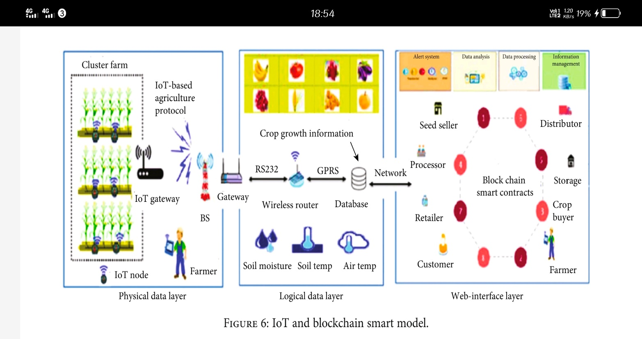

**Block Chain Integration with IoT in the Smart Model**

Exclusive blockchain characteristics will combine agricultural and food supply chain processes into a single smart system to ensure that consumers receive healthy food. Figure 7 shows a functional overview of the blockchain

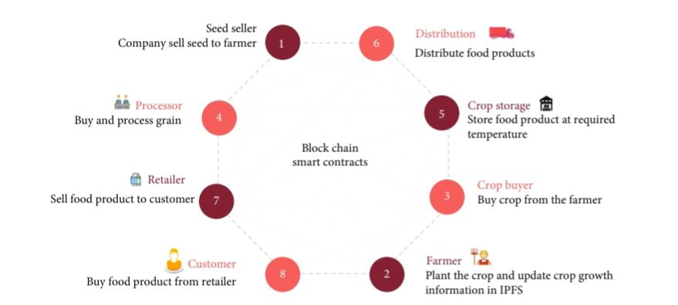

The role of stakeholders in the overall system is also discussed. The research used blockchain smart contracts to exchange data between mining nodes in the system. All business transactions are recorded in the shared ledger by mining nodes, and smart contracts receive all transactions in the blockchain in the form of function calls and generate activities, as well as providing access to parties involved in the transaction to exchange control track and receive alerts in the event of a violation. Finally, smart contracts help to maintain the best conditions and respond to food supply chain misappropriations.

**IoT-Based Agriculture Protocol for the Smart Model**

IoT nodes are ideal for cluster farms because they consume less energy than WSN and can be further reduced through an efficient clustering protocol. Therefore, this research proposed a new clustering protocol IoT-based agriculture, as shown in Figure 8, based on the LEACH protocol, to reduce energy consumption and extend network life.

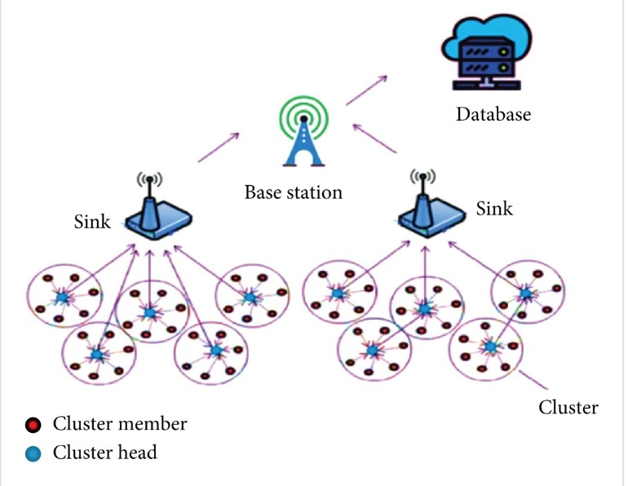

**CHAPTER 5**

**SOFTWARE AND HARDWARE REQUIRMENT**

**5.1 HARDWARE REQUIREMENTS:**

* System : Pentium Dual Core.
* Hard Disk : 120 GB.
* Monitor : 15’’ LED
* Input Devices : Keyboard, Mouse
* Ram : 4 GB

**5.2 SOFTWARE REQUIREMENTS:**

* Operating system : Windows 10
* Coding Language : python
* Tool : Python
* Database : dataset
* Server : Flask

**5.3 Hardware Interfaces**

Intel Core i5 2.00GHz Processor or each and every other processor and 200 GB min RAM 20GB Hard plate, and mouse is required.

**Software Interfaces**

The Python IDLE is an open-supply web utility that allows you to make and charge records that be essential for stay code, circumstances, portrayals, and story-printed content. Uses encompass realities cleansing and exchange, numerical re-establishment, quantifiable illustrating, realities conviction, framework examining, and divides

**CHAPTER 6**

**RESULT**

In this project we are using IOT network and Blockchain security technology in agriculture food supply chain. In propose work IOT network will be setup in agriculture farms and this IOT will sense food quality growing farms and then report to its nearest cluster head and cluster head will report to base station. Base station will collect food quality data from Cluster Head and then store that data in decentralized Blockchain nodes. This data can be access by various users such as distributors, suppliers, farmers and consumers to know the quality of the food.

All existing techniques were using centralized server (single main server) to store data and if this server hack by malicious users then they can easily alter data on that servers and user’s may get wrong or fake data and there is no proper software to detect that alteration and to overcome from this problem Blockchain technology has been introduced. Blockchain support decentralized (data stores at multiple nodes) storage and each node will store data as block of transaction by associating each block with hash code and whenever new data arrive for storage then all nodes will verify hashcode of existing blocks and if all nodes contains same hashcode then data will be consider as secured and unaltered and then new block will be added. If any node report incorrect hashcode then that node consider as attacked and then collect data from genuine nodes. Above verification of hashcode is consider as PROOF OF WORK.

Above Blockchain technology helps in detecting attack nodes and make data secured.

In propose work we are using IOT networks and this IOT network consists of following operations

1. Generate Network: using this module IOT network will get setup
2. Cluster Head Selection: all IOT networks exchange there available battery power and then check which IOT covering more number of nodes and can reached to base station with less energy consumption then that node will be elected as cluster head.
3. Collect Data: using this module IOT will collect/sense food data from agriculture farm.
4. Data Transmission Routing Phase: using this module IOT will find shortest path to reached cluster head and then transfer data to selected cluster head. CH will send data to base station. Base station will collect data and then store in Blockchain node. Blockchain store each data as block of transaction and will generate hashcode for verification
5. View Blockchain Data: various users such as consumer, farmers, distributors and many more users may use this module to retrieve data from Blockchain and view it.

In this project they have used IOT sensors and agriculture field but we don’t have any sensors so we built this concept as simulation.

SCREEN SHOTS

To run project double click on ‘run.bat’ file to get below screen

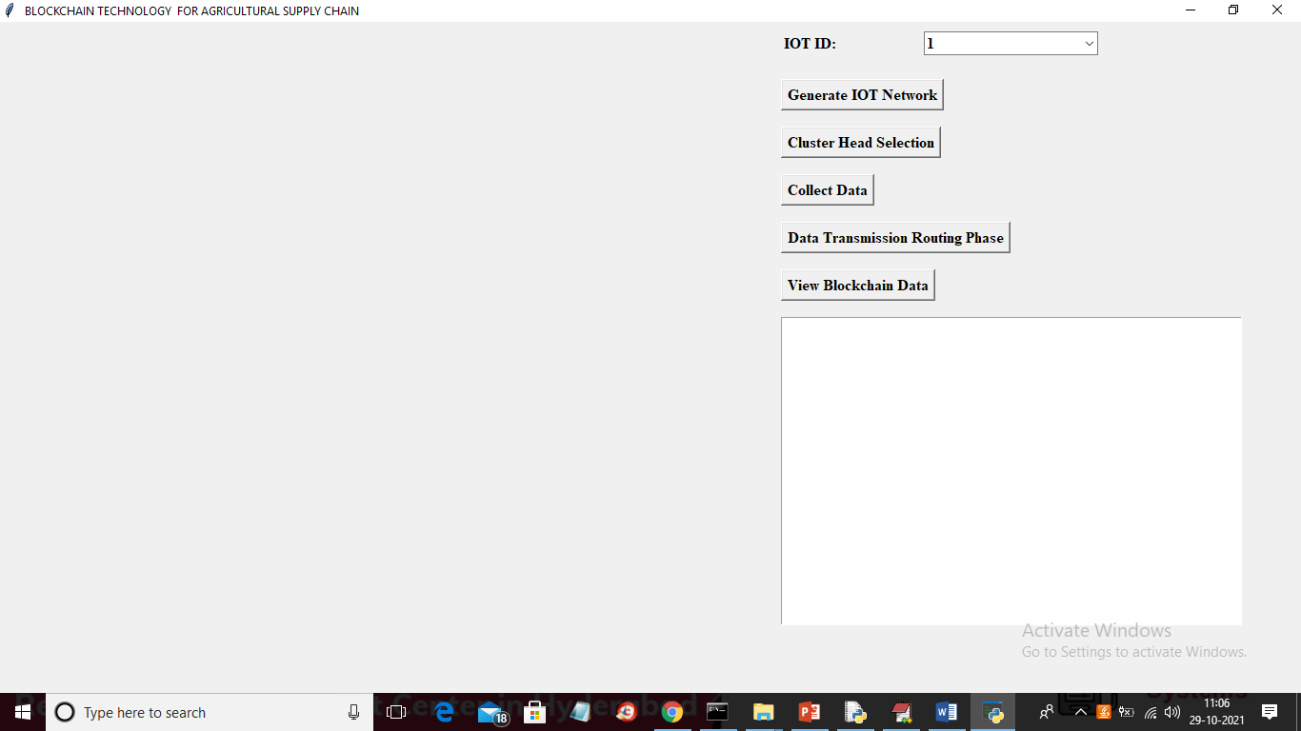

In above screen click on ‘Generate IOT Network’ button to generate IOT simulation network and to get below screen

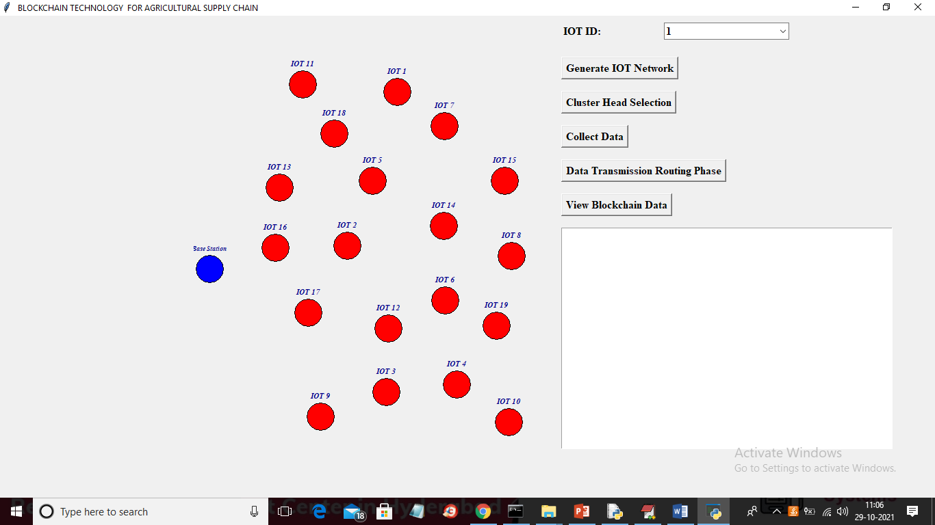

In above screen each red colour circle represents as IOT sensors installed in agriculture farms and blue colour circle represents Base Station. Now click on ‘Cluster Head Selection’ button to select cluster head with high available energy and can reach to more IOT with less distance to Base station

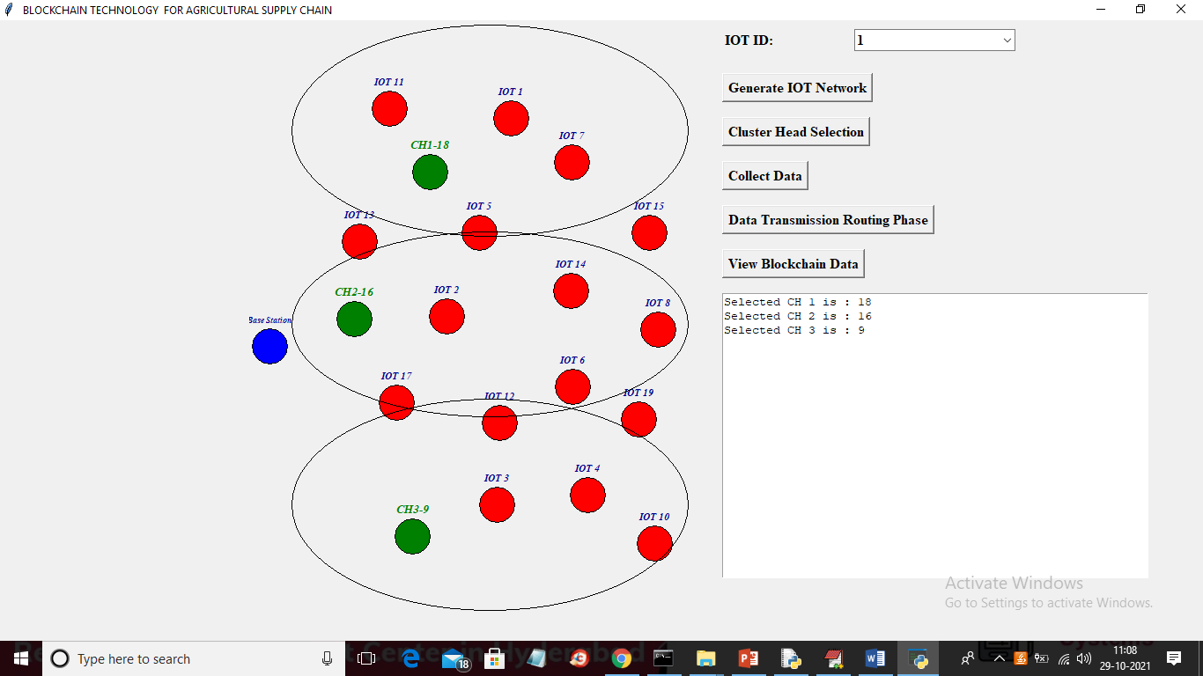

In above screen green colour IOT is selected as Cluster Head and all the IOT inside big oval will be consider as cluster member of that cluster and total 3 clusters are generated and now click on ‘Collect Data’ to enter some manual data as we don’t have any sensor to sense data so we collect data from keyboard manually

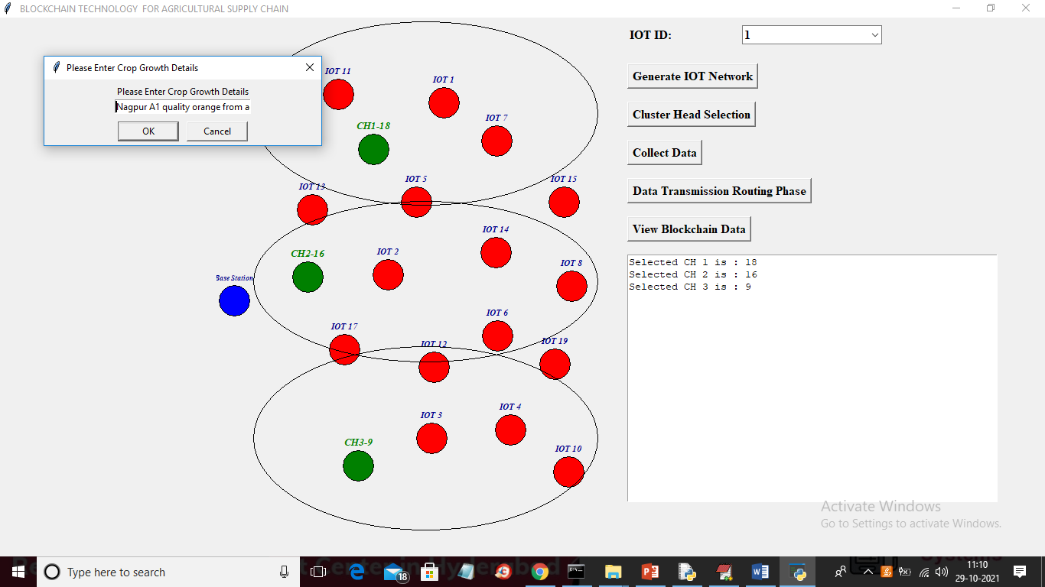

In above screen as data collection I entered some data and then click on ‘OK’ button to get below screen

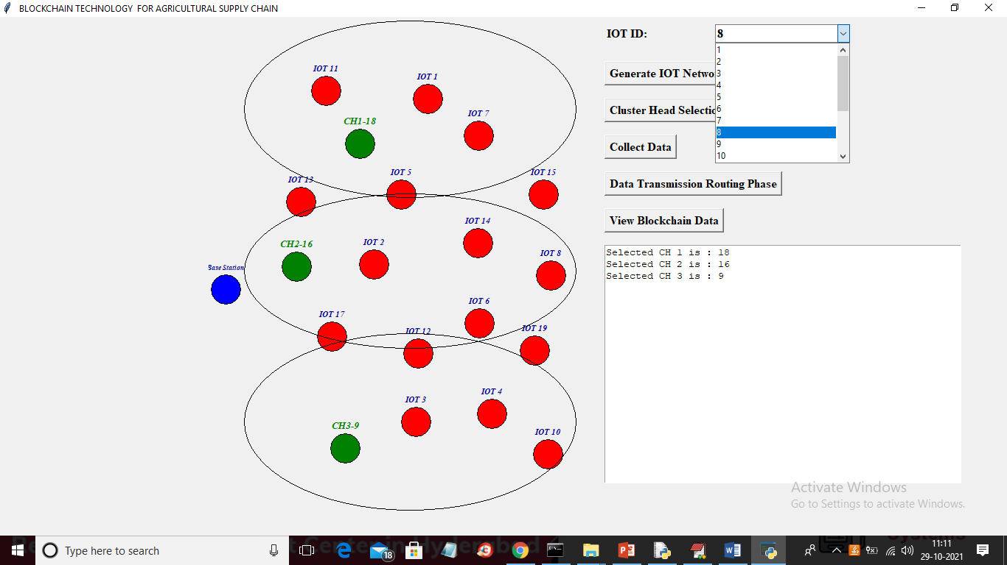

In above screen from IOT drop down box I selected sender IOT as 8 and then click on ‘Data Transmission Routing Phase’ button to allow IOT 8 to select shortest path to reached cluster head and then transfer data

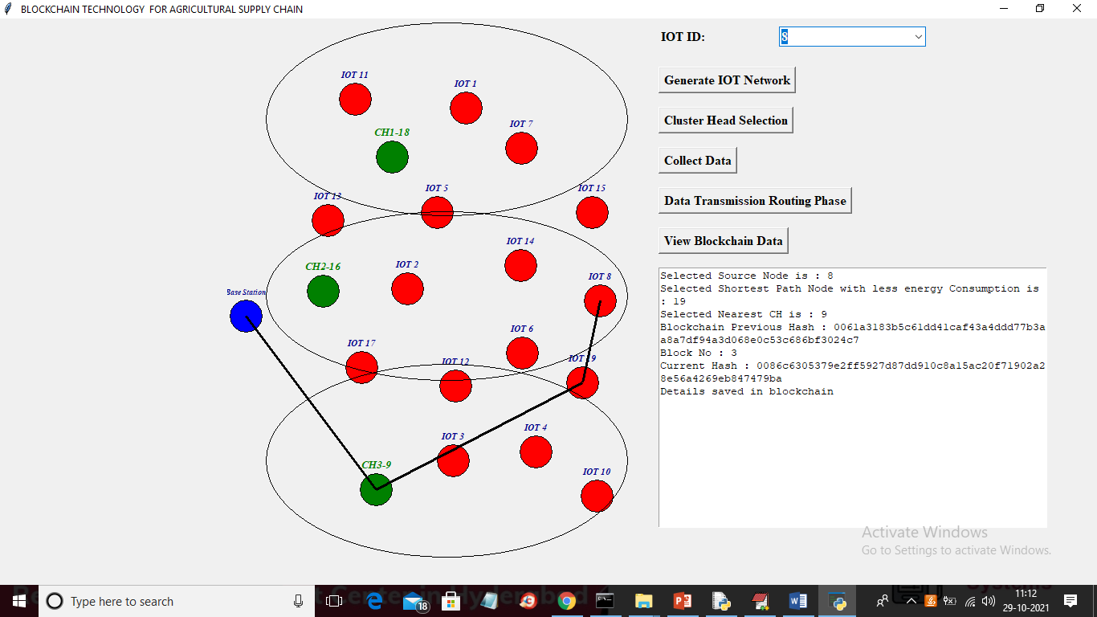

In above screen IOT 8 selected nearest hop as 9 and that 9 belongs to CH3 so it send data to CH3 and CH3 is sending data to base station and similarly you can select any IOT and then transfer data

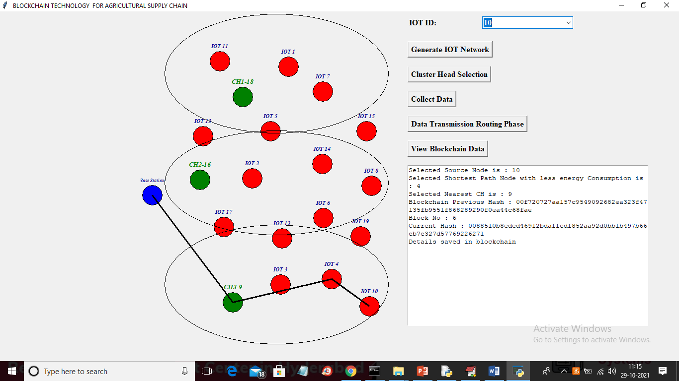

In above screen I selected IOT 10 and then it select CH 3 to send data to base station and in above screen we can see each data is stored at Blockchain and each block associated hashcode is also displaying and now select any IOT and click on ‘View Blockchain Data’ to extract data from Blockchain for selected ID

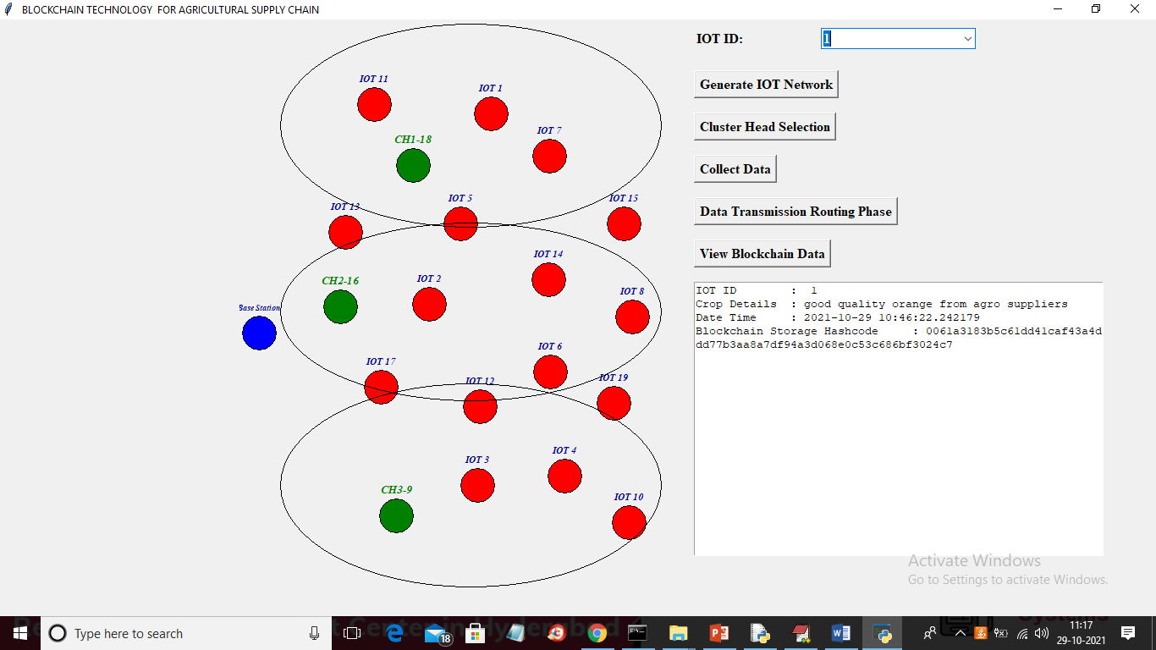

In above screen I selected IOT as 1 and then clicked on ‘View Blockchain Data’ button and then in text area all data for that IOT retrieve from Blockchain and then displaying and I am displaying hashcode of that block.

Below screen showing code for Blockchain implementation

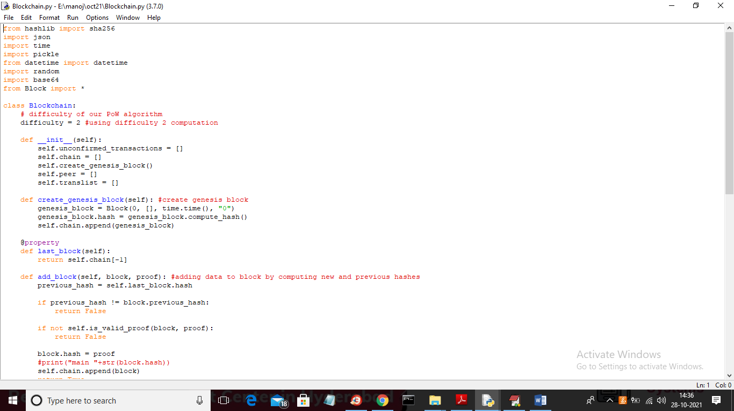

In above screen read red colour comments to know about Blockchain transaction storage

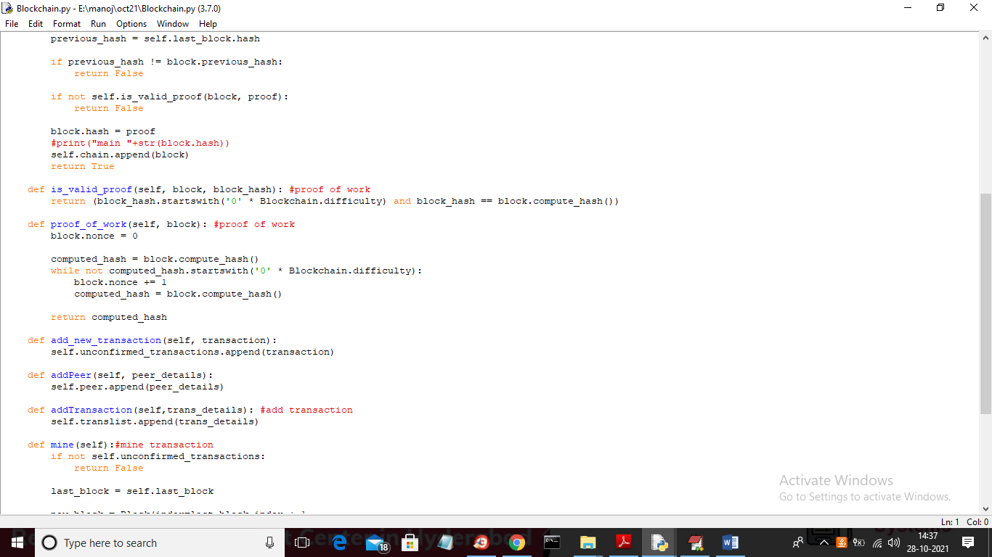

**CHAPTER 7**

**Conclusion**

Above Blockchain technology helps in detecting attack nodes and make data secured. In propose work we are using IOT networks and this IOT network implemented following operations successfully, Generate Network: Cluster Head Selection: Collect Data: Data Transmission Routing Phase: View Blockchain Data: In this project we have used IOT sensors and agriculture field but we don’t have any sensors so we built this concept as simulation and analyzed successfully.

**REFERENCES**

[1] Aiken A. Zooming in on privacy concerns: Video app Zoom is surging in popularity. In our rush to stay connected, we need to make security checks and not reveal more than we think. Index Censorsh. 2020;49(2):24–27.

[2] Bermeo-Almeida O., Cardenas-Rodriguez M., Samaniego-Cobo T., Ferruzola-Gómez E., Cabezas-Cabezas R., Bazán-Vera W. International Conference on Technologies and Innovation, 6-9 November 2018. Guayaquil; Ecuador: 2018. Blockchain in agriculture: a systematic literature review; pp. 44–56.

[3] Brewin D. The impact of COVID-19 on the grains and oilseeds sector. Can. J. Agric. Econ./Rev. Can. Agroecon. 2020;68:185–188.

[4] Chofreh A.G., Goni F.A., Jofreh M.G. Enterprise resource planning (ERP) implementation process: project management perspective. Adv. Mater. Res. 2011;338:152–155.

[5] Chofreh A.G., Goni F.A., Shaharoun A.M., Ismail S. A review on sustainability transformation roadmaps using project management methodology. Adv. Sci. Lett. 2015;21(2):133–136.

[6] Chofreh A.G., Goni F.A., Klemeš J.J. A master plan for the implementation of sustainable enterprise resource planning systems (Part II): development of a roadmap. Chem. Eng. Trans. 2016;52:1099–1104.

[7] Chofreh A.G., Goni F.A., Malik M.N., Khan H.H., Klemeš J.J. The imperative and research directions of sustainable project management. J. Clean. Prod. 2019;238A

[8] Chofreh A.G., Goni F.A., Klemeš J.J., Moosavi S.M.S., Davoudi M., Zeinalnezhad M. Covid-19 shock: development of strategic management framework for global energy. Renew. Sustain. Energy Rev. 2020;139

[9] CTA . 2017. Perspectives for ICT and Agribusiness in ACP countries: Start-up financing, 3D printing and blockchain.https://www.cta.int/en/event/perspectives-for-ict-and-agribusiness-in-acp-countries-start-up-financing-3d-printing-and-blockchain-sid002d57e47-75f4-4837-af9b-8fd5d10d5162>

[10] de Paulo Farias D., dos Santos Gomes M.G. COVID-19 outbreak: what should be done to avoid food shortages? Trends Food Sci. Technol. 2020;102:291–292.

[11] de Sousa Jabbour A.B.L., Jabbour C.J.C., Hingley M., Vilalta-Perdomo E.L., Ramsden G., Twigg D. Sustainability of supply chains in the wake of the coronavirus (COVID-19/SARS-CoV-2) pandemic: lessons and trends. Modern Suppl. Chain Res. Appl. 2020;2(3):117–122.

[12] Dujak D., Sajter D. Springer; Berlin, Germany: 2019. Blockchain Applications in Supply Chain, SMART Supply Network; pp. 21–46.

[13] Erol I., Ar I.M., Ozdemir A.I., Peker I., Asgary A., Medeni I.T., Medeni T. Assessing the feasibility of blockchain technology in industries: evidence from Turkey. J. Enterprise Inf. Manag. 2020;34(3):746–769.

[14] Events Reuters. 2018. Global blockchain market for the supply chain expected to grow at 87% CAGR until 2023.https://www.reutersevents.com/supplychain/technology/global-blockchain-market-supply-chain-expected-grow-87-cagr-until-2023>

[15] Fan Y.V., Jiang P., Hemzal M., Klemeš J.J. An update of COVID-19 influence on waste management. Sci. Total Environ. 2020;754

[16] Friese S. SAGE Publications Ltd.; London, UK: 2019. Qualitative Data Analysis with ATLAS. Ti.

[17] Galanakis C.M. The food systems in the era of the coronavirus (COVID-19) pandemic crisis. Foods. 2020;9(4):523.A

[18] Galvez J.F., Mejuto J.C., Simal-Gandara J. Future challenges on the use of blockchain for food traceability analysis. Trac. Trends Anal. Chem. 2018;107:222–232.

[19] Goni F.A., Shukor S.A., Mukhtar M., Sahran S. Environmental sustainability: research growth and trends. Adv. Sci. Lett. 2015;21(2):192–195.

[20] Grain Chain. 2020. Creating supply chain efficiency. https://www.grainchain.io/>

[21] Gray R.S. Agriculture, transportation, and the COVID-19 crisis. Can. J. Agric. Econ./Rev. Can. Agroecon. 2020;68:239–243.

[22] Gurtu A., Johny J. Potential of blockchain technology in supply chain management: a literature review. Int. J. Phys. Distrib. Logist. Manag. 2019;49(9):881–900.

[23] Hailu G. Economic thoughts on COVID-19 for Canadian food processors. Can. J. Agric. Econ./Rev. Can. Agroecon. 2020;68(2):163–169.

[24] Haley E., Caxaj S., George G., Hennebry J., Martell E., McLaughlin J. Migrant farmworkers face heightened vulnerabilities during COVID-19. J. Agric., Food Syst. Commun. Dev. 2020;9(3):1–5.

[25] Hewson C. In: The SAGE Handbook of Online Research Methods. second ed. Fielding N.G., Lee R.M., Blank G., editors. SAGE Publications Ltd.; London, UK: 2017. Research design and tools for online research; pp. 57–75.

[26] Hobbs J.E. Food supply chains during the COVID‐19 pandemic. Can. J. Agric. Econ./Rev. Can. Agroecon. 2020;68(2):171–176

[27] Hoffman A., Munsterman R. 2018. Dreyfus teams with banks for first agriculture blockchain trade.https://www.bloomberg.com/news/articles/2018-01-22/dreyfus-teams-with-banks-for-first-agriculture-blockchain-trade>

[28] Huberman A.M., Miles M., Saldana J. fourth ed. SAGE Publications, Inc.; Thousand Oaks, California, USA: 2014. Qualitative Data Analysis: A Methods Sourcebook.

[29] Jamal S. 2020. How will COVID-19 affect Pakistan farmers, food system?https://gulfnews.com/world/asia/pakistan/how-will-covid-19-affect-pakistan-farmers-food-system-1.71196910>

[30] Jameel M. IIASA; Laxenburg, Austria: 1982. Energy for Agriculture in Pakistan. IIASA Research Report.

[31] JUMIA . 2020. COVID-19: UNDP, JUMIA Uganda partner to link market vendors with consumers online.https://group.jumia.com/covid-19-undp-jumia-uganda-partner-to-link-market-vendors-with-consumers-online/>

[32] Kalla A., Hewa T., Mishra R.A., Ylianttila M., Liyanage M. The role of blockchain to fight against COVID-19. IEEE Eng. Manag. Rev. 2020;48(3):85–96

**APPENDIX**

**PYTHON**

**1.1 Introduction**

* One of the most popular languages is Python. Guido van Rossum released this language in 1991. Python is available on the Mac, Windows, and Raspberry Pi operating systems. The syntax of Python is simple and identical to that of English. When compared to Python, it was seen that the other language requires a few extra lines.

*It is an interpreter-based language because code may be run line by line after it has been written. This implies that rapid prototyping is possible across all platforms. Python is a big language with a free, binary-distributed interpreter standard library.

* It is inferior to maintenance that is conducted and is straightforward to learn. It is an object-oriented, interpreted programming language. It supports several different programming paradigms in addition to object-oriented programming, including functional and procedural programming.

* It supports several different programming paradigms in addition to object-oriented programming, including practical and procedural programming. Python is mighty while maintaining a relatively straightforward syntax. Classes, highly dynamic data types, modules, and exceptions are covered. Python can also be utilised by programmes that require programmable interfaces as an external language.

Here are some key features and characteristics of Python:

* Readability: Python emphasizes code readability with its clean and intuitive syntax. It uses indentation and whitespace to structure code blocks, making it easy to understand and maintain.
* Easy to Learn: Python's simplicity and readability make it an excellent choice for beginners. Its straightforward syntax and extensive documentation make it accessible for newcomers to programming.
* Interpreted Language: Python is an interpreted language, meaning that it doesn't need to be compiled before running. The Python interpreter reads and executes the code directly, making the development process faster and more interactive.
* Cross-platform Compatibility: Python is available for major operating systems like Windows, macOS, and Linux. This cross-platform compatibility allows developers to write code once and run it on different platforms without modifications.
* Large Standard Library: Python comes with a vast standard library that provides ready-to-use modules and functions for various tasks. It covers areas such as file I/O, networking, regular expressions, databases, and more, saving developers time and effort.
* Extensible and Modular: Python supports modular programming, enabling developers to organize code into reusable modules and packages. Additionally, Python allows integrating modules written in other languages, such as C or C++, providing flexibility and performance optimizations.
* Wide Range of Libraries and Frameworks: Python has a vibrant ecosystem with numerous third-party libraries and frameworks. These libraries, such as NumPy, pandas, TensorFlow, and Django, extend Python's capabilities for specific domains, making it a powerful tool for diverse applications.
* Object-Oriented: Python supports object-oriented programming (OOP) principles, allowing developers to create and work with classes and objects. OOP provides a structured approach to code organization, promoting code reuse and modularity.
* Dynamic Typing: Python is dynamically typed, meaning variable types are determined at runtime. Developers do not need to declare variable types explicitly, which enhances flexibility and simplifies code writing.

**1.2 Installation**

To install Python on your computer, follow these basic steps:

* Step 1: Visit the Python website Go to the official Python website at <https://www.python.org/>.
* Step 2: Select the operating system Choose the appropriate installer for your operating system. Python supports Windows, macOS, and various Linux distributions. Make sure to select the correct version that matches your operating system.
* Step 3: Check which version of Python is installed; if the 3.7.0 version is not there, uninstall it through the control panel and
* Step 4: Install Python 3.7.0 using Cmd.
* Step 5: Install the all libraries that required to run the project
* Step 6: Run

**1.3 Python Features:**

1. **Easy:** Because Python is a more accessible and straightforward language, Python programming is easier to learn.
2. **Interpreted language:** Python is an interpreted language, therefore it can be used to examine the code line by line and provide results.
3. **Open Source:** Python is a free online programming language since it is open-source.
4. **Portable:** Python is portable because the same code may be used on several computer standard
5. **libraries:** Python offers a sizable library that we may utilize to create applications quickly.
6. **GUI:** It stands for GUI (Graphical User Interface)
7. **Dynamical typed:** Python is a dynamically typed language, therefore the type of the value will be determined at runtime.

**1.4 Python GUI (Tkinter)**

* Python provides a wide range of options for GUI development (Graphical User Interfaces).
* Tkinter, the most widely used GUI technique, is used for all of them.
* The Tk GUI toolkit offered by Python is used with the conventional Python interface.
* Tkinter is the easiest and quickest way to write Python GUI programs.
* Using Tkinter, creating a GUI is simple.
* A part of Python's built-in library is Tkinter. The GUI programs were created.
* Python and Tkinter together give a straightforward and quick way. The Tk GUI toolkit's object-oriented user interface is called Tkinter.

Making a GUI application is easy using Tkinter. Following are the steps:

1) Install the Tkinter module in place.

2) The GUI applicatioMakeske the primary window

3) Include one or more of the widgets mentioned above in the GUI application.

4) Set up the main event loop such that it reacts to each user-initiated event.

Although Tkinter is the only GUI framework included in the Python standard library, Python includes a GUI framework. The default library for Python is called Tkinter. Tk is a scripting language often used in designing, testing, and developing GUIs. Tk is a free, open-source widget toolkit that may be used to build GUI applications in a wide range of computer languages.

**1.5 Python IDLE**

* Python IDLE offers a full-fledged file editor, which gives you the ability to write and execute Python programs from within this program. The built-in file editor also includes several features, like code completion and automatic indentation, that will speed up your coding workflow.
* Guido Van Rossum named Python after the British comedy group Monty Python while the name IDLE was chosen to pay tribute to Eric Idle, who was one of the Monty Python's founding members. IDLE comes bundled with the default implementation of the Python language since the 01.5. 2b1 release
* IDLE is used to execute statements similar to Python Shell. IDLE is used to create, modify, and execute Python code. IDLE provides a fully-featured text editor to write Python scripts and provides features like syntax highlighting, auto-completion, and smart indent.
* IDLE has two modes: interactive and script. We wrote our first program, “Hello, World!” in interactive mode. Interactive mode immediately returns the results of commands you enter into the shell. In script mode, you will write a script and then run it.
* The IDE Python IDLE is a good place to start as it helps you become familiar with the way Python works and understand its syntax. This IDE is good to start programming in Python due to its great debugger, but once you are fluent and start developing projects it is necessary to jump to another, more complete IDE.
* Python IDLE (Integrated Development and Learning Environment) is an interactive development environment included with the Python programming language. It provides a convenient way to write, execute, and debug Python code.

When you install Python, IDLE is typically installed along with it. To open IDLE, you can follow these steps:

* Open the command prompt (Windows) or terminal (macOS/Linux).
* Type "idle" and press Enter. Alternatively, you can specify the version with "idle3" or "idle2" for Python 3 or Python 2, respectively.
* Once IDLE is launched, you will see the Python shell, which is an interactive environment where you can type and execute Python code directly.

Here are some features and functionalities provided by Python IDLE:

* Editor: IDLE includes a text editor where you can write your Python code. It offers syntax highlighting, automatic indentation, and code completion to enhance your coding experience.
* Interactive Shell: The Python shell in IDLE allows you to execute Python code interactively. You can type commands, statements, or function calls directly in the shell, and Python will execute them immediately.
* Debugging: IDLE provides basic debugging capabilities to help you find and fix errors in your code. You can set breakpoints, step through code, inspect variables, and track the program's execution.
* Python Help: IDLE provides access to the Python documentation and built-in help. You can access the help menu to find information about Python modules, functions, classes, and more.
* Script Execution: In addition to the interactive shell, IDLE allows you to run Python scripts stored in files. You can write your code in the editor and execute it as a script to see the output or interact with the program.
* Customization: IDLE can be customized to suit your preferences. You can modify settings related to syntax highlighting, indentation, fonts, and more.
* Python IDLE serves as a beginner-friendly development environment and learning tool. It is suitable for writing small scripts, testing code snippets, experimenting with Python features, and learning the language's basics. However, for more advanced development projects, you may consider using other code editors or integrated development environments (IDEs) that provide additional features and better project management capabilities.

**1.6 Libraries**

In Python, libraries (also referred to as modules or packages) are collections of pre-written code that provide additional functionality and tools to extend the capabilities of the Python language. Libraries contain reusable code that developers can leverage to perform specific tasks without having to write everything from scratch.

Python libraries are designed to solve common problems, such as handling data, performing mathematical operations, interacting with databases, working with files, implementing networking protocols, creating graphical user interfaces (GUIs), and much more. They provide ready-to-use functions, classes, and methods that simplify complex operations and save development time.

**Libraries in Python offer various advantages:**

* Code Reusability:
* Efficiency:
* Collaboration
* Domain-Specific Functionality
* To use a Python library, you need to install it first.

There are some libraries following:

* **Pandas:**

Pandas are a Python computer language library for data analysis and manipulation. It offers a specific operation and data format for handling time series and numerical tables. It differs significantly from the release3-clause of the BSD license. It is a well-liked open-source of opinion that is utilized in machine learning and data analysis.

Pandas are a Python package providing fast, flexible, and expressive data structures designed to make working with “relational” or “labeled” data both easy and intuitive. It aims to be the fundamental high-level building block for doing practical, real-world data analysis in Python. Pandas are a Python library used for working with data sets.

* It has functions for analysing, cleaning, exploring, and manipulating data.
* The name "Pandas" has a reference to both "Panel Data", and "Python Data Analysis" and was created by Wes McKinney in 2008.
* Pandas allow us to analyse big data and make conclusions based on statistical theories.
* Pandas can clean messy data sets, and make them readable and relevant.

Relevant data is very important in data science. Pandas are a Python library for data analysis. Started by Wes McKinney in 2008 out of a need for a powerful and flexible quantitative analysis tool, pandas have grown into one of the most popular Python libraries. It has an extremely active community of contributors. The name is derived from the term "panel data", an econometrics term for data sets that include observations over multiple time periods for the same individuals. Its name is a play on the phrase "Python data analysis" itself.

* **NumPy:**

The NumPy Python library for multi-dimensional, big-scale matrices adds a huge number of high-level mathematical functions. It is possible to modify NumPy by utilizing a Python library. Along with line, algebra, and the Fourier transform operations, it also contains several matrices-related functions.

NumPy can be used to perform a wide variety of mathematical operations on arrays. It adds powerful data structures to Python that guarantee efficient calculations with arrays and matrices and it supplies an enormous library of high-level mathematical functions that operate on these arrays and matrices.

* NumPy is a Python library used for working with arrays.
* It also has functions for working in domain of linear algebra, Fourier transform, and matrices.
* NumPy was created in 2005 by Travis Oliphant. It is an open source project and you can use it freely.
* NumPy stands for Numerical Python.
* In Python we have lists that serve the purpose of arrays, but they are slow to process.
* NumPy aims to provide an array object that is up to 50x faster than traditional Python lists.
* The array object in NumPy is called ndarray, it provides a lot of supporting functions that make working with ndarray very easy.
* Arrays are very frequently used in data science, where speed and resources are very important.
* **Matplotlib:**

It is a multi-platform, array-based data visualization framework built to interact with the whole SciPy stack. MATLAB is proposed as an open-source alternative. Matplotlib is a Python extension and a cross-platform toolkit for graphical plotting and visualization.

Matplotlib is a popular Python library for creating static, animated, and interactive visualizations. It provides a flexible and comprehensive set of tools for generating plots, charts, histograms, scatter plots, and more. Matplotlib is widely used in various fields, including data analysis, scientific research, and data visualization.

Here are some key features and functionalities of the Matplotlib library:

* Plotting Functions
* Customization Options
* Multiple Interfaces
* Integration with NumPy and pandas
* Subplots and Figures:
* Saving and Exporting
* **Scikit-learn:**

The most stable and practical machine learning library for Python is scikit-learn. Regression, dimensionality reduction, classification, and clustering are just a few of the helpful tools it provides through the Python interface for statistical modeling and machine learning. It is an essential part of the Python machine learning toolbox used by JP Morgan. It is frequently used in various machine learning applications, including classification and predictive analysis.

Scikit-learn (also referred to as sklearn) is a widely used open-source machine learning library for Python. It provides a comprehensive set of tools and algorithms for various machine learning tasks, including classification, regression, clustering, dimensionality reduction, model selection, and pre-processing.

Here are some key features and functionalities of the Scikit-learn library:

* Easy-to-Use Interface:
* Broad Range of Algorithms:
* Data Pre-processing and Feature Engineering:
* Model Evaluation and Validation:
* Integration with NumPy and pandas:
* Robust Documentation and Community Support:
* **Keras:**

* Google's Keras is a cutting-edge deep learning API for creating neural networks. It is created in Python and is designed to simplify the development of neural networks. Additionally, it enables the use of various neural networks for computation. Deep learning models are developed and tested using the free and open-source Python software known as Keras.

Keras is a high-level deep learning library for Python. It is designed to provide a user-friendly and intuitive interface for building and training deep learning models. Keras acts as a front-end API, allowing developers to define and configure neural networks while leveraging the computational backend engines, such as Tensor Flow or Theano.

Here are some key features and functionalities of the Keras library:

* User-Friendly API
* Multi-backend Support
* Wide Range of Neural Network Architectures
* Pre-trained Models and Transfer Learning:
* Easy Model Training and Evaluation:
* GPU Support:
* **h5py:**

* The h5py Python module offers an interface for the binary HDF5 data format. Thanks to p5py, the top can quickly halt the vast amount of numerical data and alter it using the NumPy library. It employs common syntax for Python, NumPy, and dictionary arrays.

h5py is a Python library that provides a simple and efficient interface for working with datasets and files in the Hierarchical Data Format 5 (HDF5) format. HDF5 is a versatile data format commonly used for storing and managing large volumes of numerical data.

Here are some key features and functionalities of the h5py library:

* + HDF5 File Access
  + Dataset Handling:
  + Group Organization:
  + Attributes:
  + Compatibility with NumPy
  + Performance
* **Tensor flow**

TensorFlow is a Python library for fast numerical computing created and released by Google. It is a foundation library that can be used to create Deep Learning models directly or by using wrapper libraries that simplify the process built on top of TensorFlow. TensorFlow is an end-to-end open source platform for machine learning. TensorFlow is a rich system for managing all aspects of a machine learning system; however, this class focuses on using a particular TensorFlow API to develop and train machine learning models.

TensorFlow is a popular open-source library for machine learning and deep learning. It provides a comprehensive set of tools, APIs, and computational resources for building and training various types of machine learning models, especially neural networks.

Here are some key features and functionalities of TensorFlow:

* Neural Network Framework:
* Computational Graphs
* Automatic Differentiation
* GPU and TPU Support
* Distributed Computing
* Deployment Capabilities
* **Tkinter**

Tkinter is an acronym for "Tk interface". Tk was developed as a GUI extension for the Tcl scripting language by John Ousterhout. The first release was in 1991. Tkinter is the de facto way in Python to create Graphical User interfaces (GUIs) and is included in all standard Python Distributions. In fact, it's the only framework built into the Python standard library.

Tkinter is a standard Python library used for creating graphical user interfaces (GUIs). It provides a set of modules and classes that allow you to develop interactive and visually appealing desktop applications.

Here are some key features and functionalities of Tkinter:

* Cross-Platform Compatibility
* Simple and Easy-to-Use
* Widgets and Layout Management
* Event-Driven Programming
* Customization and Styling
* Integration with Other Libraries
* **NLTK**

NLTK is a toolkit build for working with NLP in Python. It provides us various text processing libraries with a lot of test datasets. A variety of tasks can be performed using NLTK such as tokenizing, parse tree visualization, etc NLTK (Natural Language Toolkit) is the go-to API for NLP (Natural Language Processing) with Python. It is a really powerful tool to pre-process text data for further analysis like with ML models for instance. It helps convert text into numbers, which the model can then easily work with.

NLTK (Natural Language Toolkit) is a Python library widely used for working with human language data and implementing natural language processing (NLP) tasks. It provides a set of tools, corpora, and resources for tasks such as tokenization, stemming, tagging, parsing, sentiment analysis, and more.

Here are some key features and functionalities of NLTK:

* Text Processing
* Part-of-Speech Tagging
* Named Entity Recognition
* Chunking and Parsing
* Sentiment Analysis:
* WordNet Integration:
* **Scipy**

SciPy is a collection of mathematical algorithms and convenience functions built on the NumPy extension of Python. It adds significant power to the interactive Python session by providing the user with high-level commands and classes for manipulating and visualizing data.

SciPy is a powerful scientific computing library for Python that provides a wide range of mathematical algorithms and functions. It builds upon NumPy, another fundamental library for numerical computing, and extends its capabilities by adding additional tools for scientific and technical computing tasks.

Here are some key features and functionalities of SciPy:

* Numerical Integration:
* Optimization and Root Finding
* Linear Algebra
* Signal and Image Processing
* Statistics